First event under the Project 621810-CITIZ-1-2020-1-BG-CITIZ-NT "Europe of diversity - integration and socialization of migrants", under the Programme "Europe for citizens", Measure 2.2 - Networks of towns
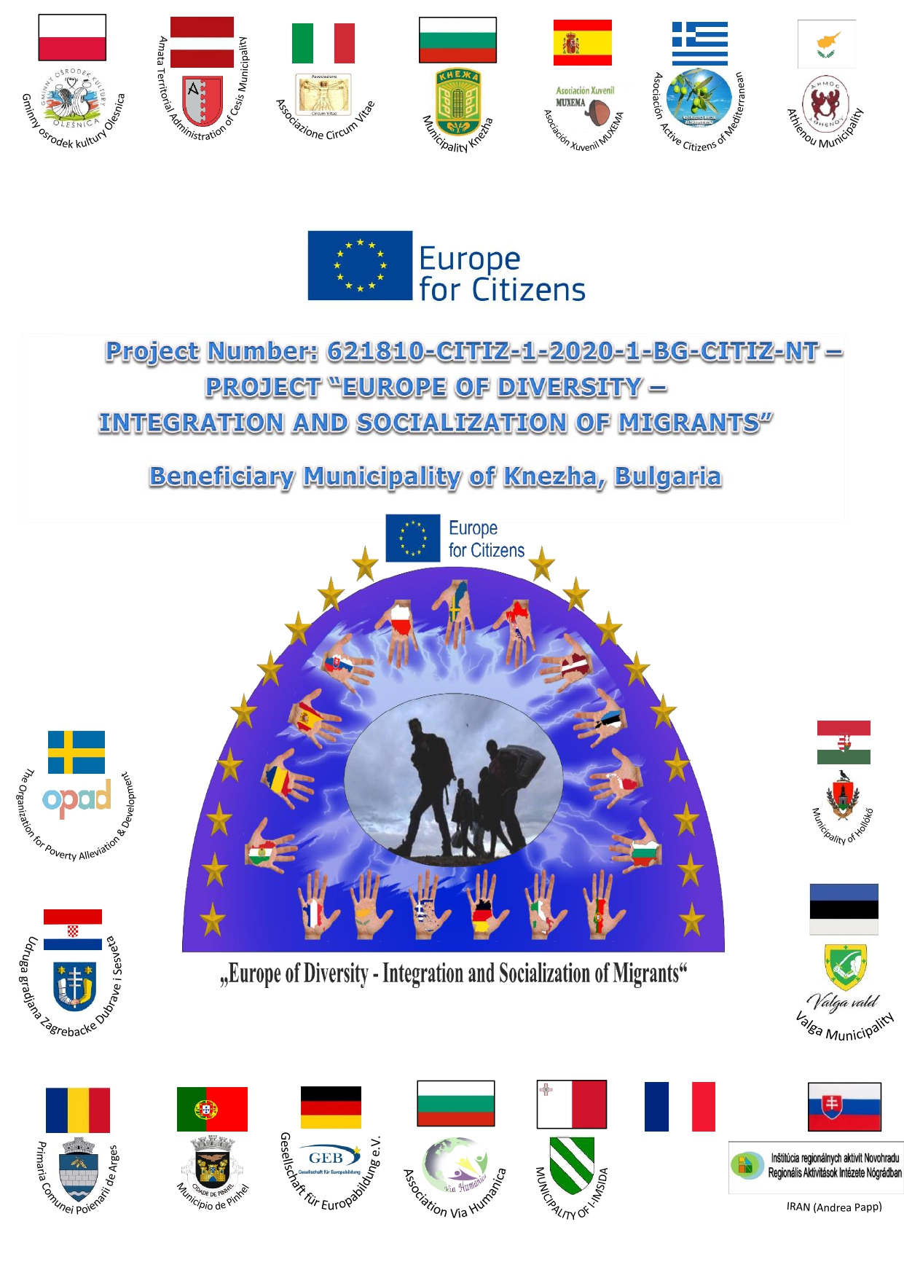
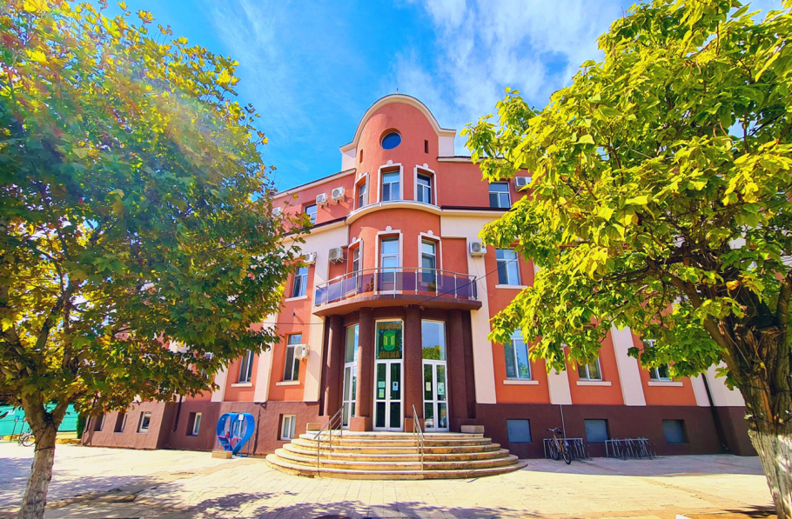

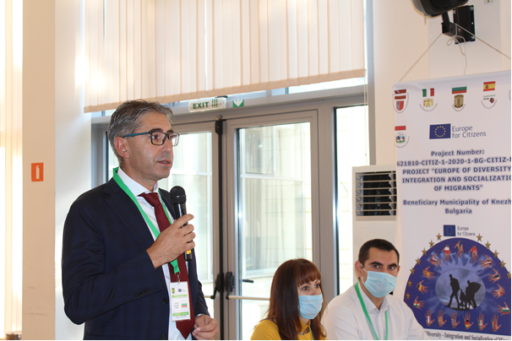
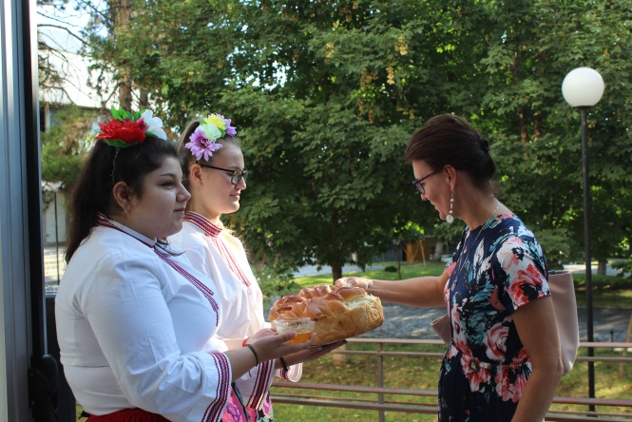
In the period between August 30 and September 3, 2021, the Municipality of Knezha hosted and organized the first official meeting under the project "Europe of Diversity - Integration and Socialization of Migrants" within the framework of the "Europe for Citizens" program, Direction 2 - Networks of Cities . As a beneficiary of the project, the Municipality of Knezha traditionally welcomed participants from 17 countries - Spain, Germany, France, Hungary, Italy, Malta, Latvia, Portugal, Estonia, Slovakia, Poland, Sweden, Romania, Croatia, Greece, Cyprus, and Bulgaria - SNC Via Humanica - city of Pleven. The event began with a solemn opening and welcome by the Mayor of Knezha Municipality - Mr. Iliicho Lachovski.

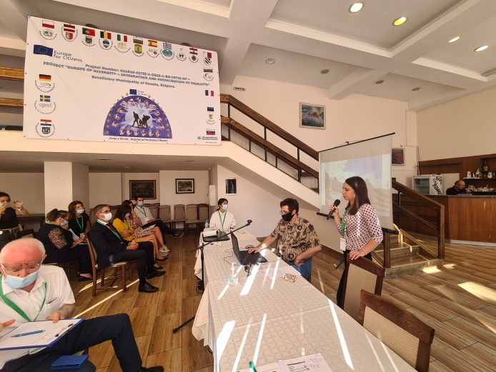
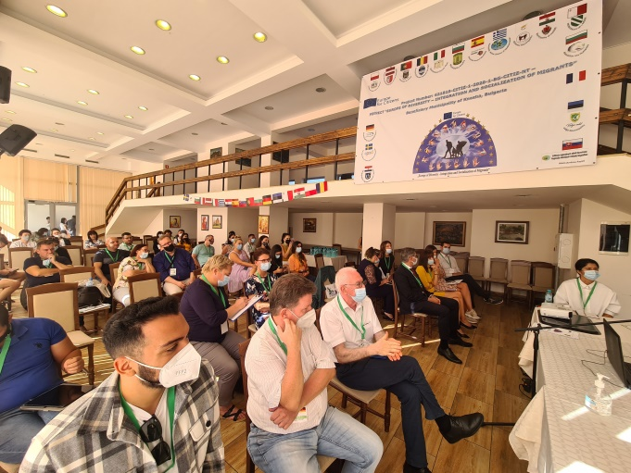
The activities and goals of the project were presented, as well as presentations on the nature of migration and the concept of a migrant. All partners presented themselves, as well as the activities of the organizations they represent.
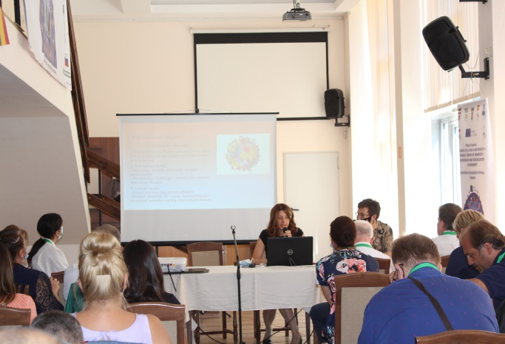
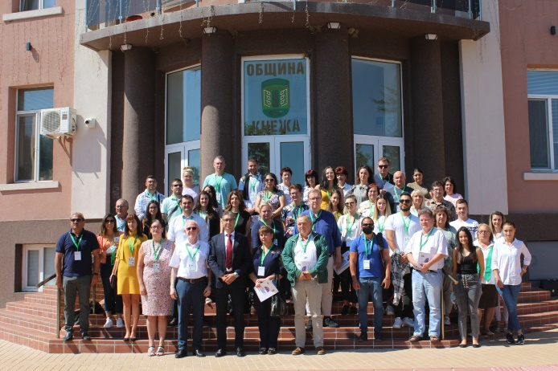
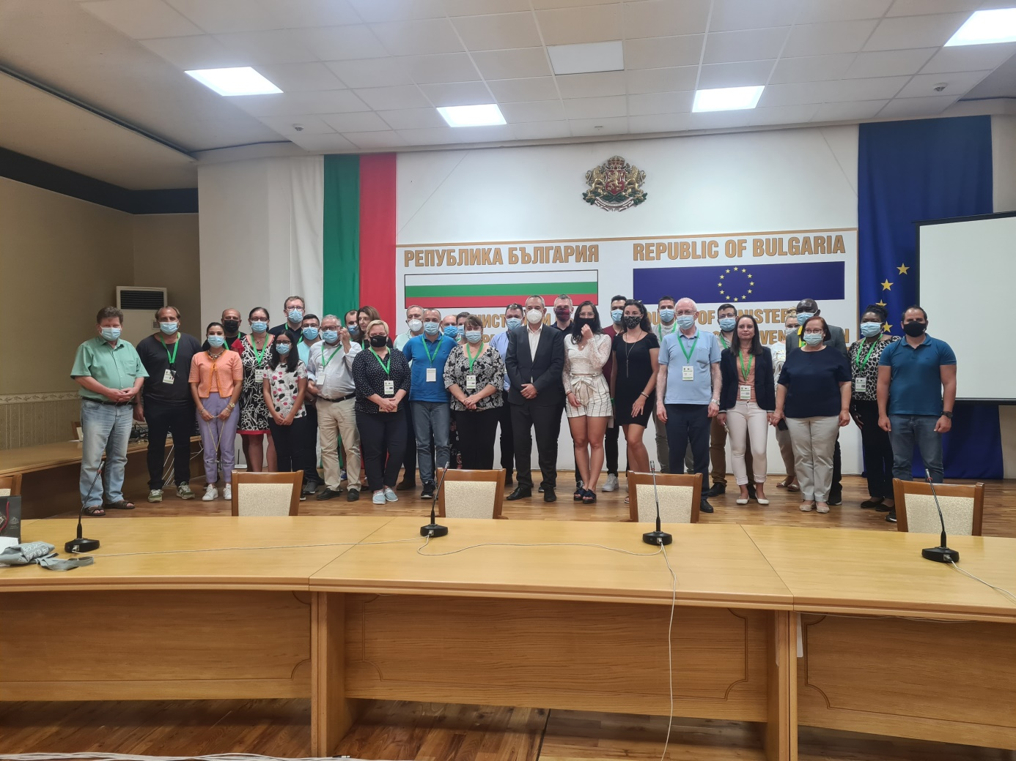
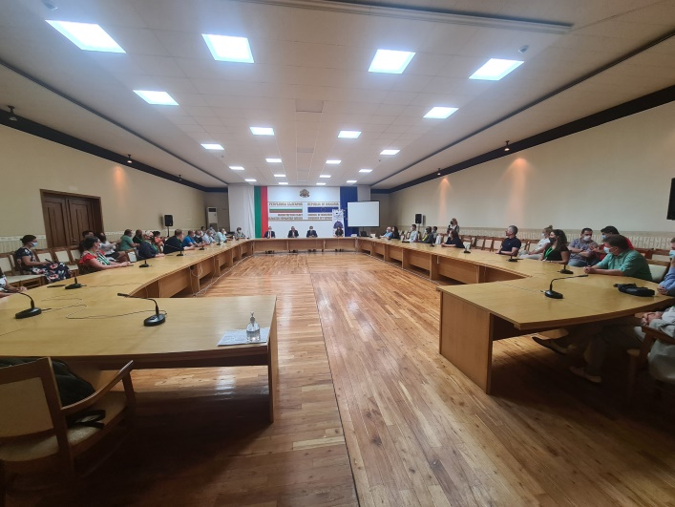
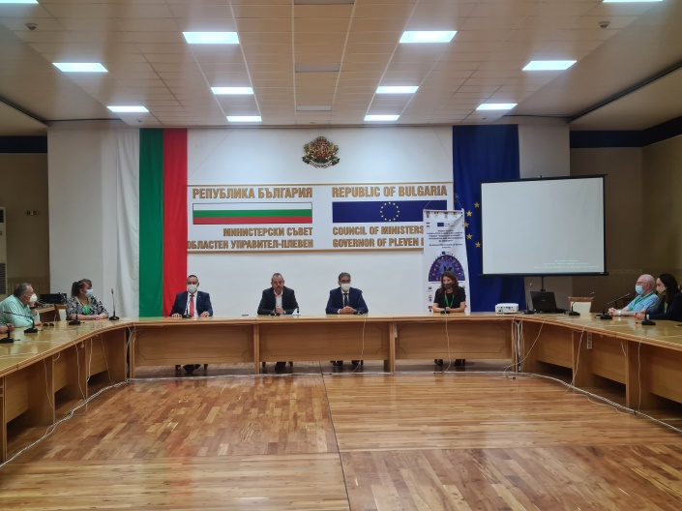
A meeting was held on September 01, 2021 in the Pleven Regional Administration, where the guests were welcomed by Mr. Mario Todorov - Regional Governor of the Pleven Region, with whom they discussed the topic "Migration - integration and socialization of migrants".

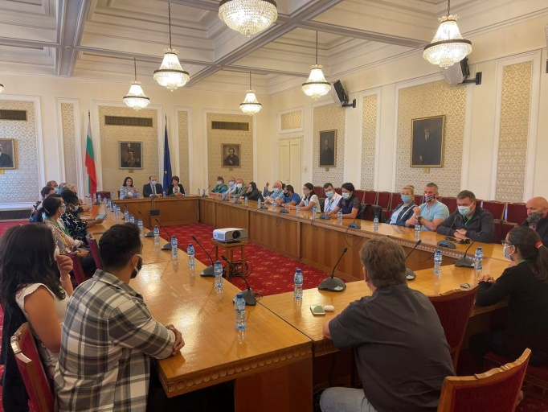
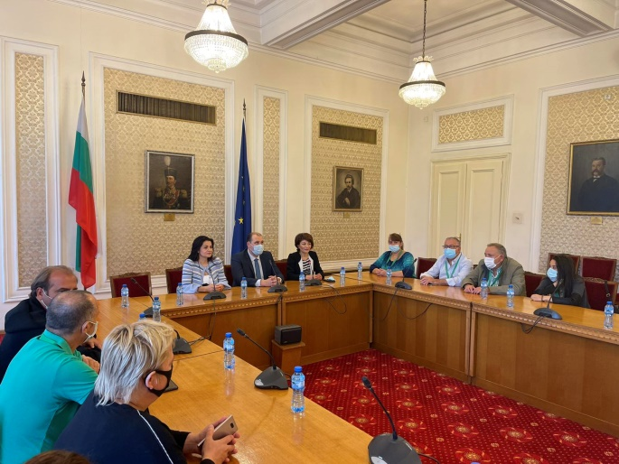
On September 2, 2021, the project participants visited the National Assembly of the Republic of Bulgaria, where they were welcomed by Mr. Valeri Lachovski - Member of Parliament in the 46th National Assembly from the Pleven multi-mandate electoral district. The guests were also welcomed by the people's representatives Desislava Atanasova and Rositsa Kirova. The participants made a presentation of their organizations and, together with the people's representatives present, touched on the topic of "Migration - economic, political and social consequences".
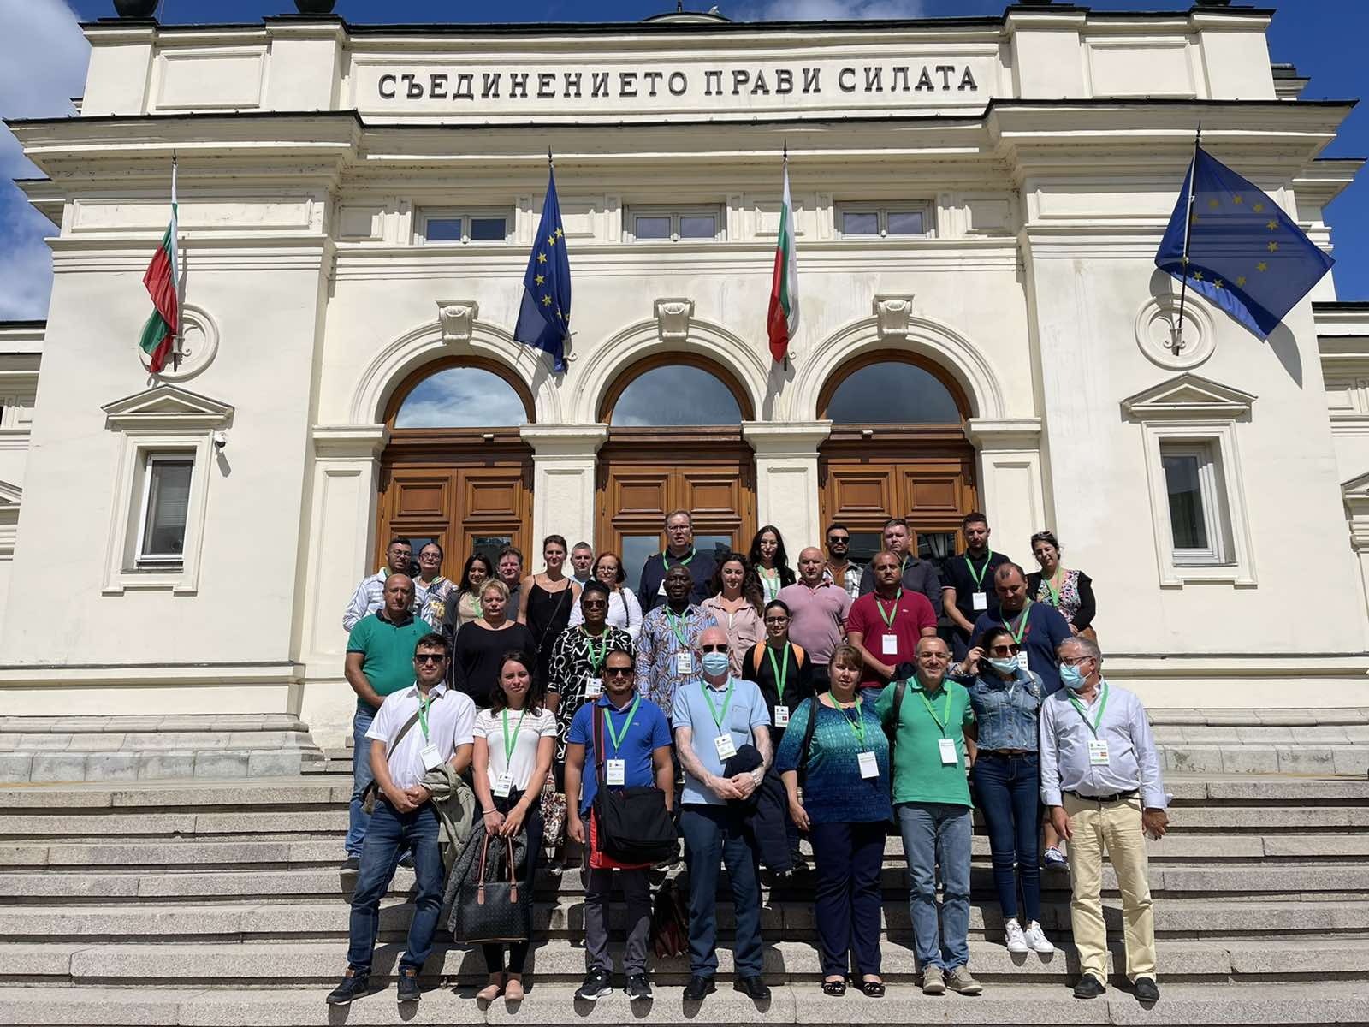

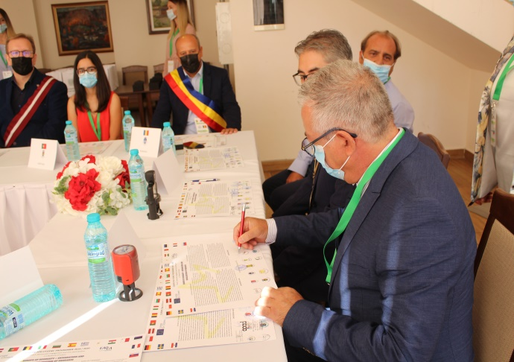
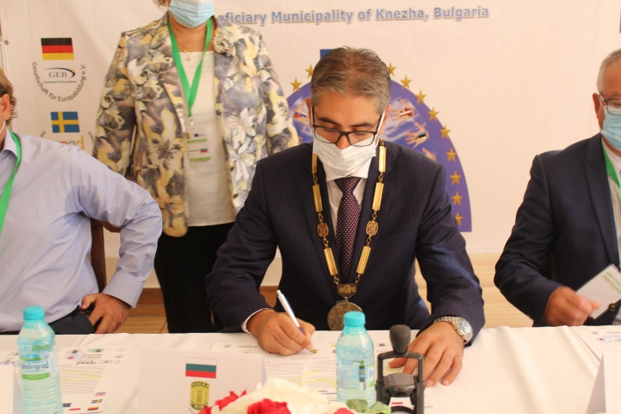
With an official ceremony of signing a Contract/Pact for the twinning of the Municipality of Knezha with municipalities and organizations from: Bulgaria, Spain, Germany, France, Hungary, Italy, Malta, Latvia, Portugal, Estonia, Slovakia, Poland, Sweden, Romania, Croatia, Greece and Cyprus, a common goal was set to create a long-term network open to the values of friendship, solidarity, intercultural dialogue between the countries.

"With this contract, we set the stage for good international relations and future implementation of joint projects," said Mr. Iliicho Lachovski - Mayor of Knezha Municipality
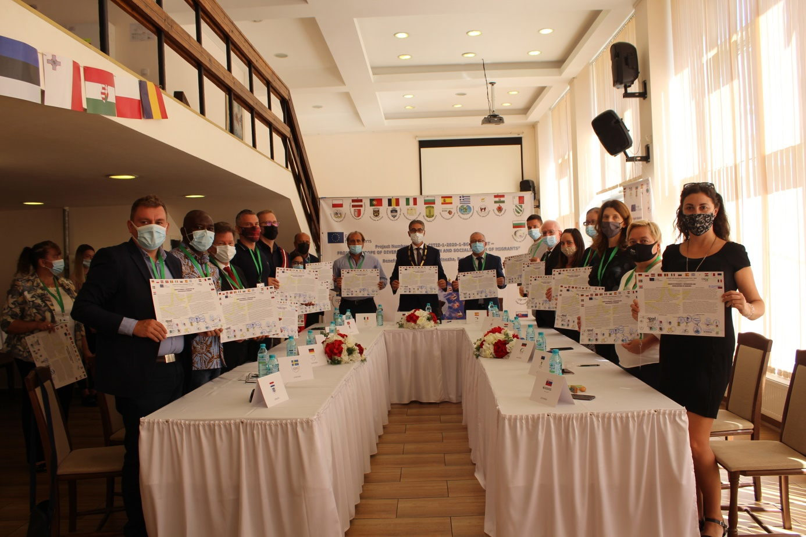
Until the end of the project, there are 4 more events to be held in another four partner cities from the countries included in the project.

