Fifth event under The Project 621810-CITIZ-1-2020-1-BG-CITIZ-NT "Europe of diversity - integration and socialization of migrants", under the Programme "Europe for citizens", Measure 2.2 - Networks of towns

The last Fifth event under The Project 621810-CITIZ-1-2020-1-BG-CITIZ-NT "Europe of diversity - integration and socialization of migrants", under the programme "Europe for citizens", Measure 2.2 - Networks of cities was held in from September 19 to September 22, 2022 in Holoko, Hungary.
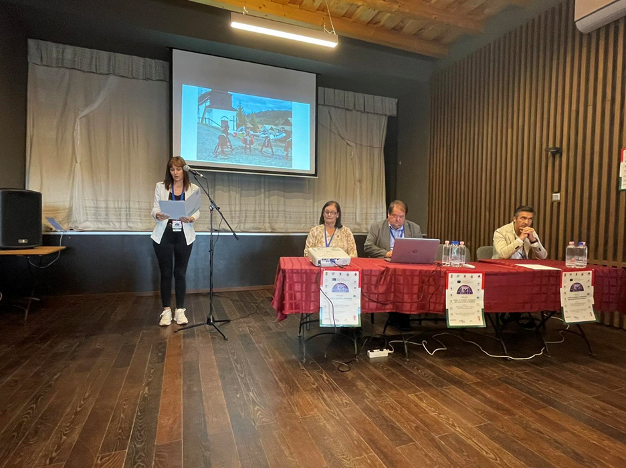
The purpose of the event was to bring together the project partners for the last time, as well as to summarize the needs of citizens and local authorities by exchanging good practices on issues related to migration and European diversity. Like every past event, this one also started with a welcome of the delegations and a greeting from the Mayor of Holoko - Mr. Csaba Szabo. On behalf of the Municipality of Knezha - a leading partner in the project, a congratulatory address was made by Mrs. Kapka Miteva - Deputy Mayor of the Municipality of Knezha, who also welcomed the participants and guests of the event.

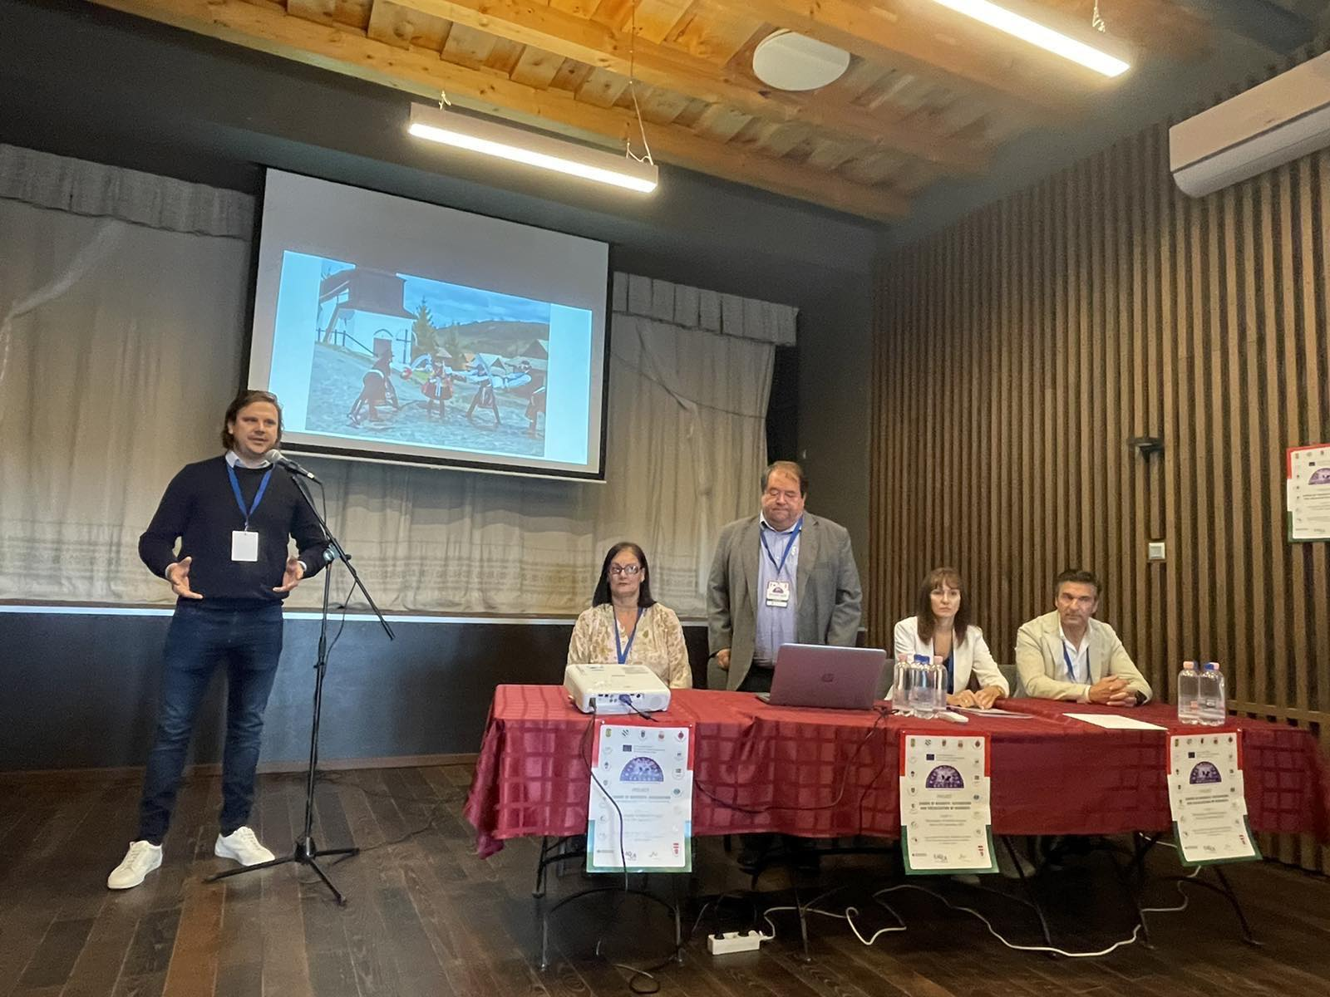During the event, a round table was organized on the topic "Integration and socialization of migrants in the European Union".
An open debate was also held on the topic "Local, regional and European migration policies", with the participation of all partners, local experts and representatives of non-governmental organizations.
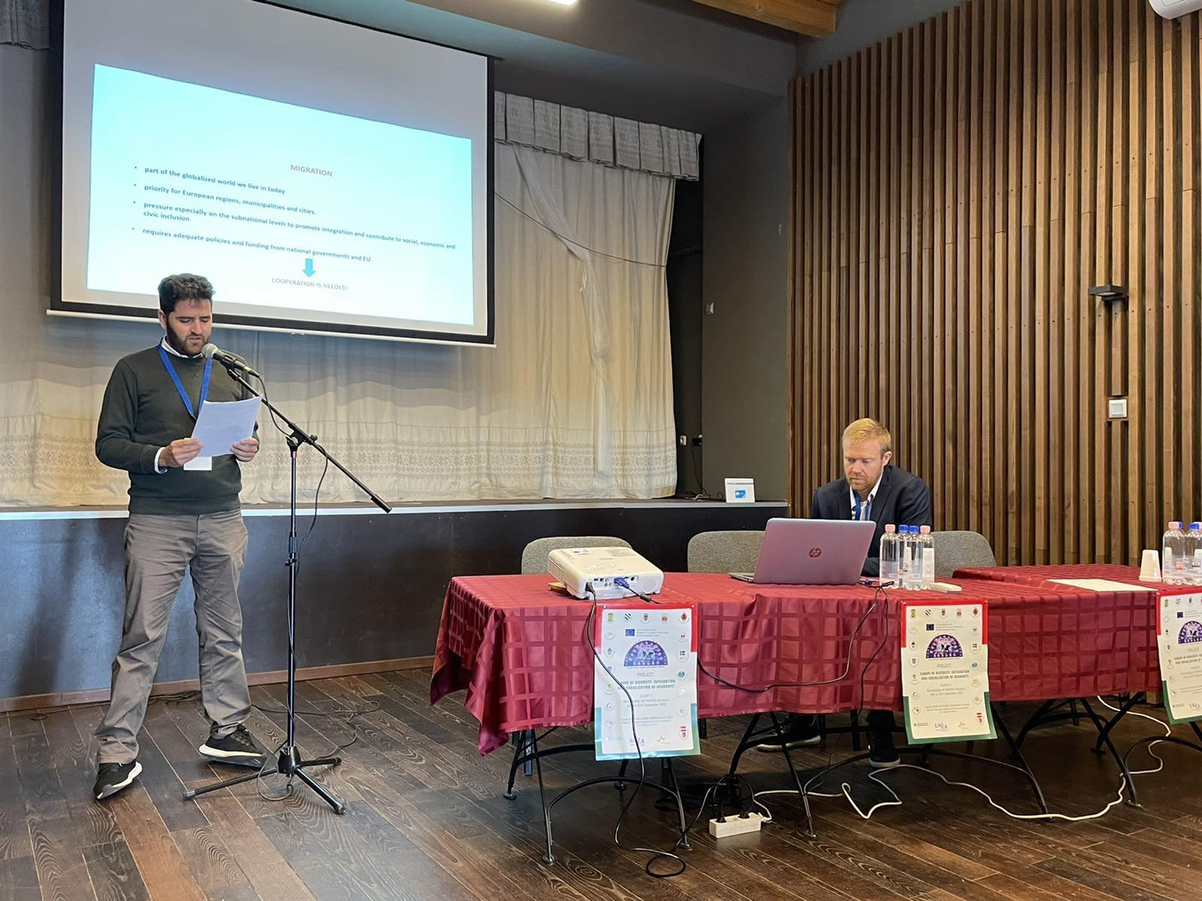

At a conference organized in the Parliament of Hungary, the delegations were welcomed by representatives of the local government.
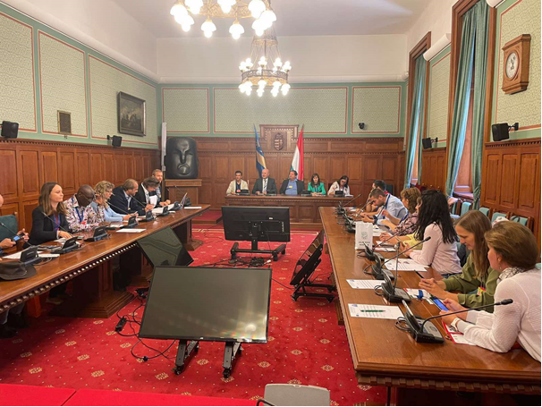
A discussion was held on "Is the labor market open to immigrants?" and the partner views on "Diversity + integration = European Engagement" were presented. The opinions and positions of the partners on these topics are collected in an information brochure prepared and distributed to the participants during the event.
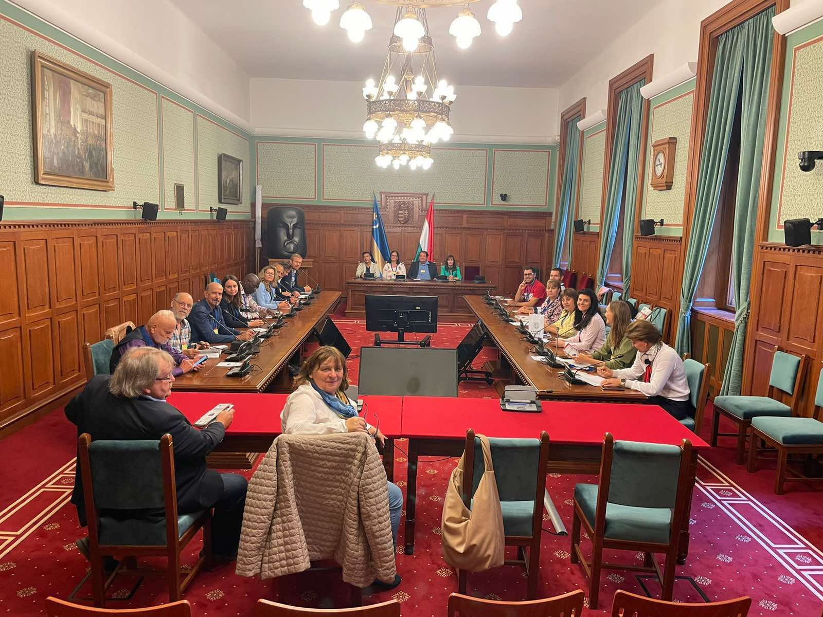

At a closing ceremony of the project, which was attended by local politicians, citizens and guests from the region, a video was presented with key moments and fond memories of the overall implementation of all events of the project "Europe of Diversity - Integration and Socialization of Migrants".
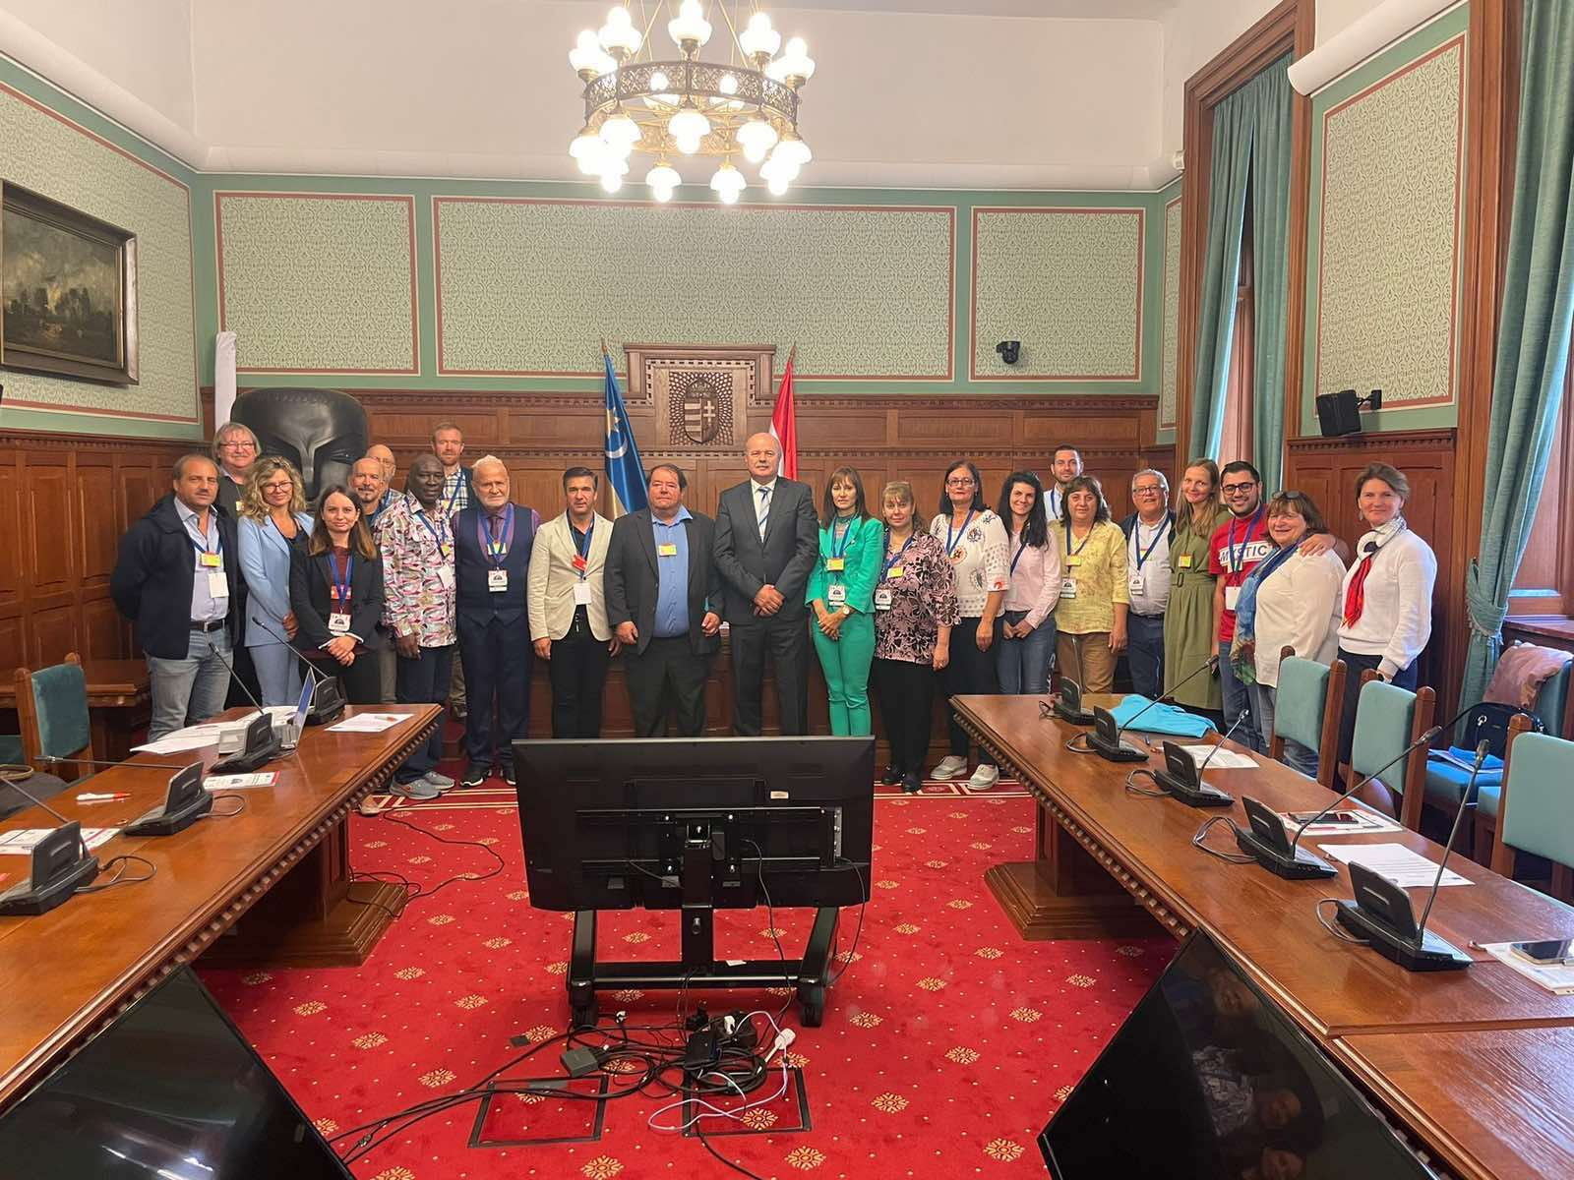

All participants in the meetings received certificates for participation in the project activities.
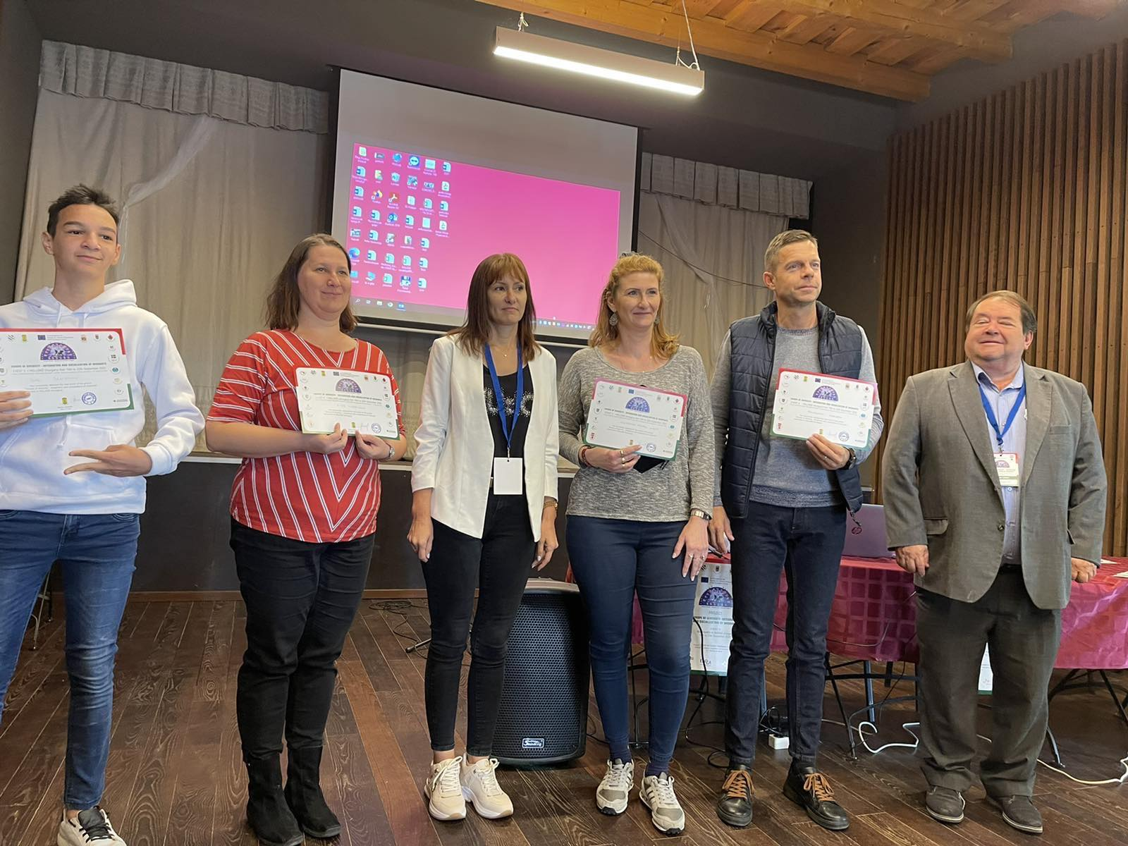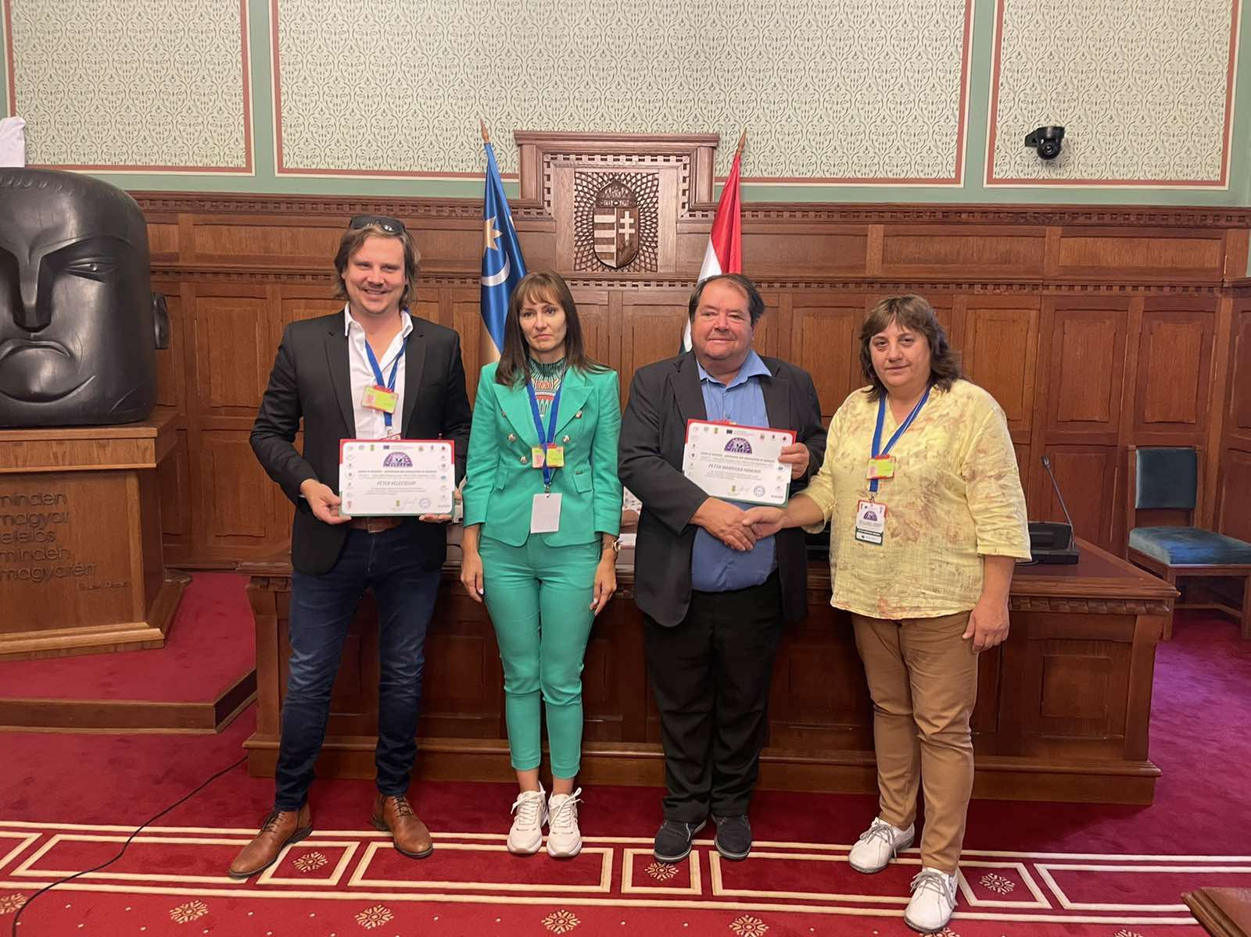

Within the framework of the event, the achieved results of the project were summarized and proposals for new projects arising from the cooperation network of the partner organizations were discussed.
