Project "Europe of Diversity - Integration and Socialization of Migrants"
Strand 2: Measure 2.2 "Networks of towns"
Europe for Citizens Programme
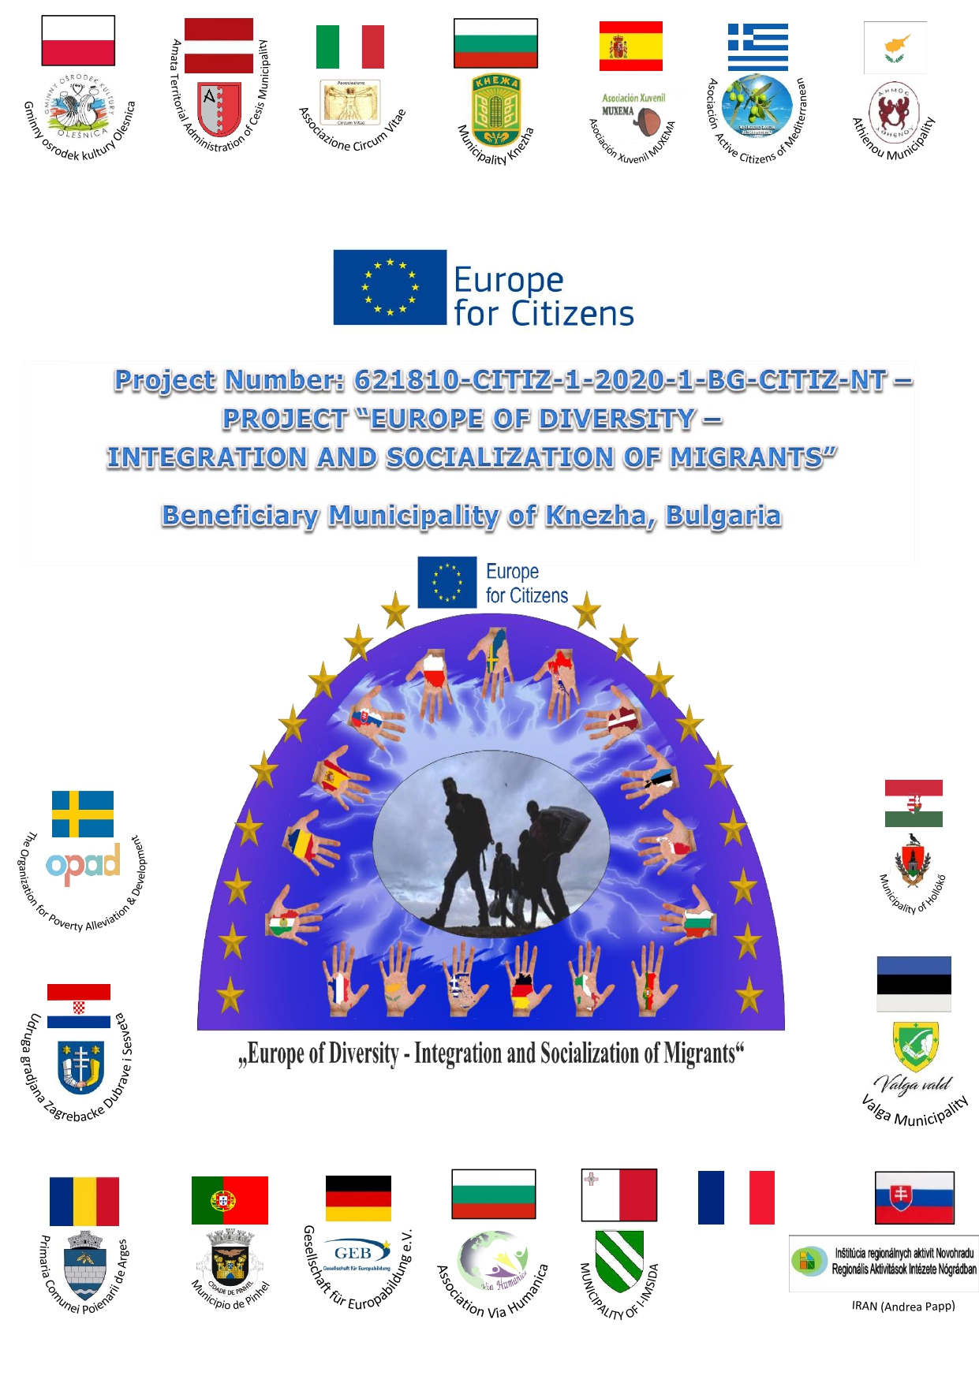

The project "Europe of diversity - integration and socialization of migrants" under measure 2.2. Networks of towns, of Europe for Citizens programme, is a project whose main objective is to seek understanding, integration and the creation of new perspectives through dialogue and reflection on European citizens, helping to better understand the European Union on migrant issues, as well as its history and diversity of citizens, promoting European citizenship, increasing civic and democratic participation, as well as understanding the current position of the EU regarding new migration policies and the search for alternatives and new challenges to overcome the problems, caused by the migrant crisis.
The planned activities strengthened the active participation of citizens in the European society, and during each event a series of round tables, interactive seminars, meetings - talks, conferences, case studies, cultural visits, etc. were included in the program. Each activity required the active participation of citizens with a focus on migrants, associations, non-governmental organizations, politicians, experts, public administrations, cultural, social and economic actors and citizens who had never participated in this type of project.

Partners in the project are 18 municipalities and non-governmental organizations from 17 member states of the European Union.

The project includes the municipality of Knezha (Bulgaria) - beneficiary of the project and the partners: the city of Pleven (Bulgaria), the city of Holoko (Hungary), the municipality of Negreira (Spain), the city of Berlin (Germany), the city of Santa Teresa di Riva (Italy), the city of L- Imsida (Malta), city of Amata (Latvia), city of Pinel (Portugal), city of Valga (Estonia), city of Kolonda (Slovakia), city of Olesnica (Poland), city of Stockholm (Sweden), municipality of Poienarii de Arges (Romania), city Zagreb (Croatia), the city of Thessaloniki (Greece) and the village of Atienou (Cyprus).

5 thematic meetings were held in 5 different countries:

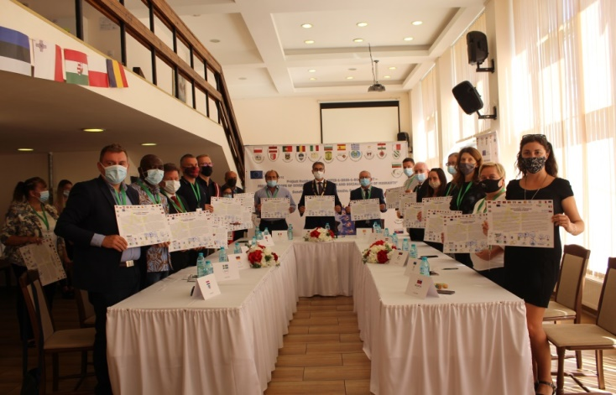
- Event 1: in the city of Knezha (Bulgaria) from 30/08/2021 to 03/09/2021.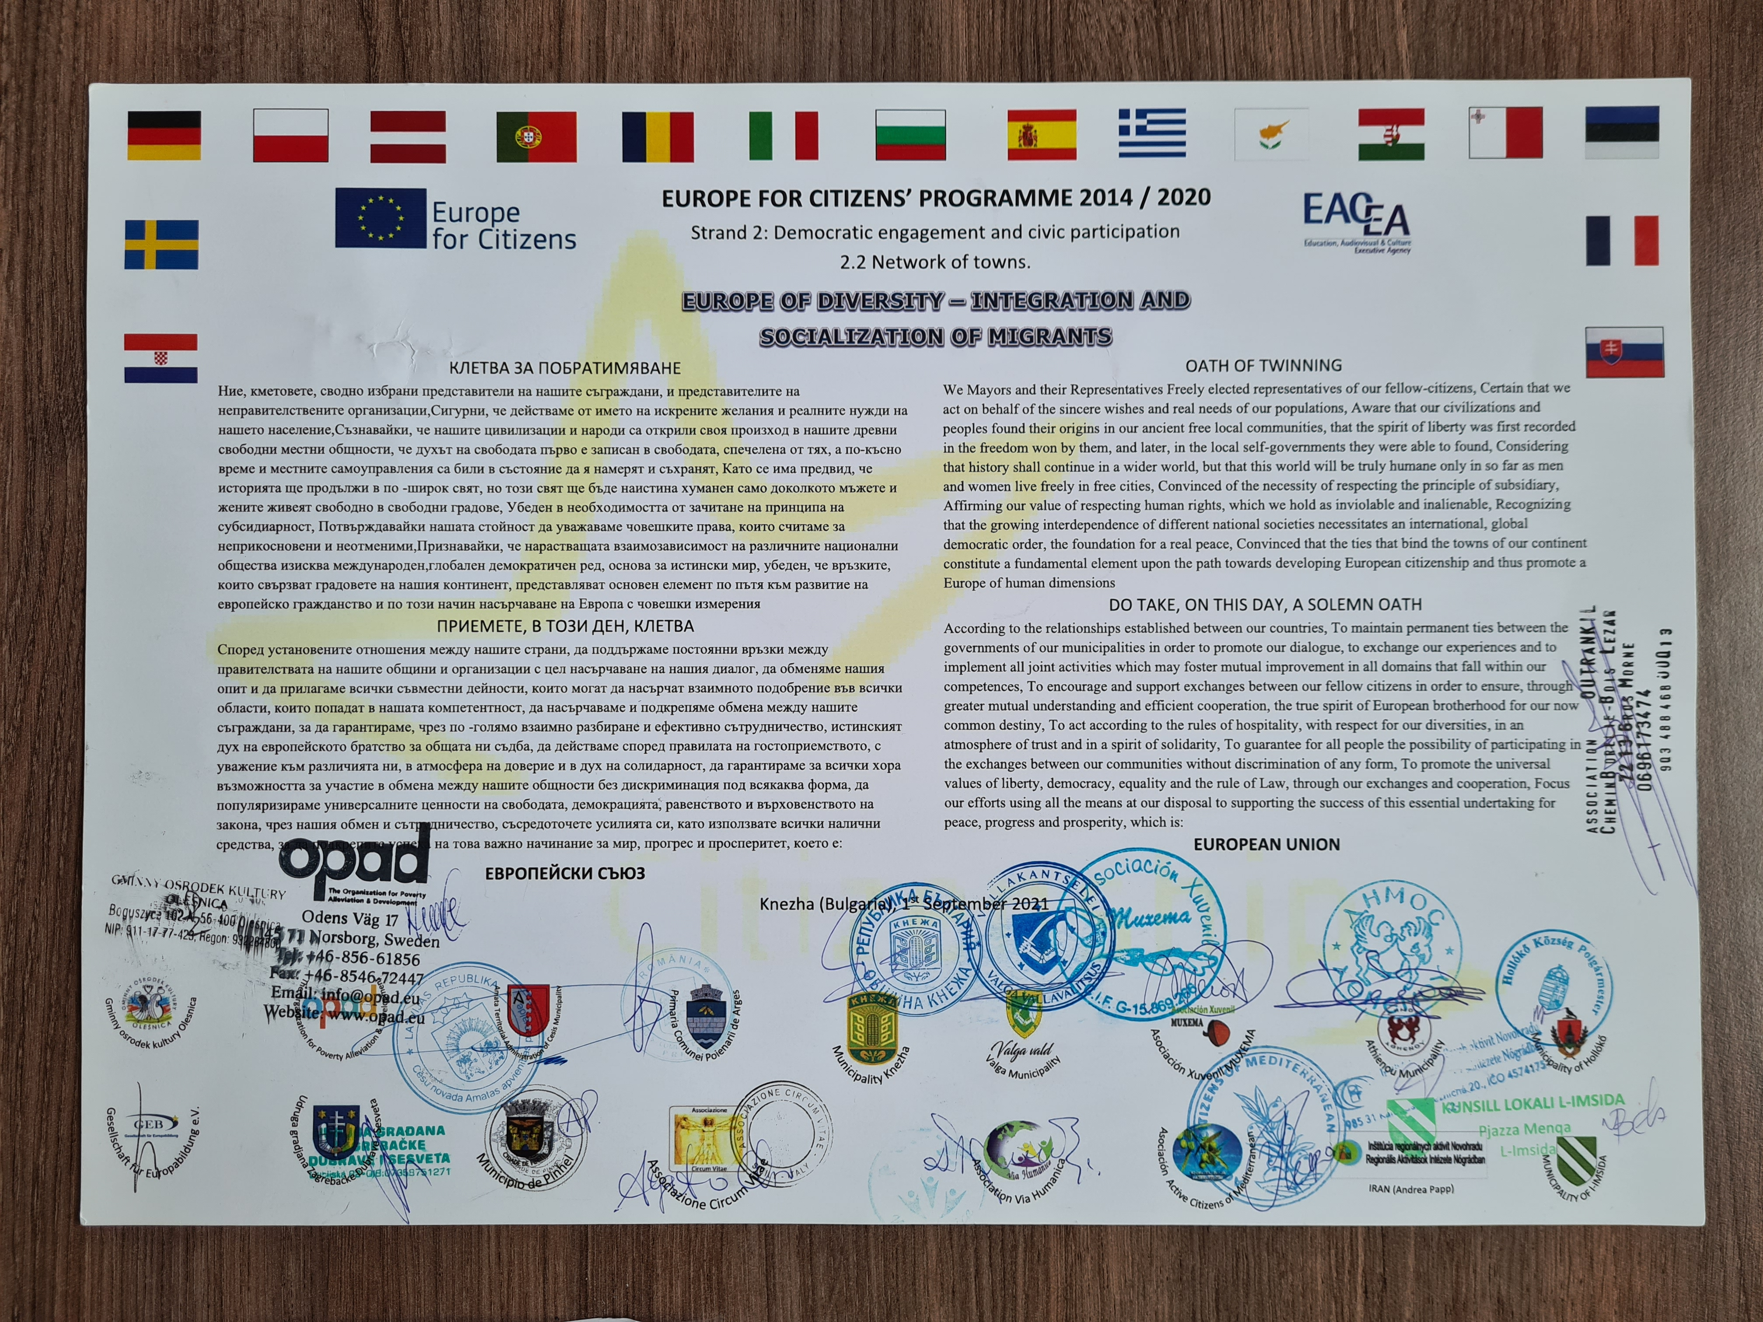
The project was approached through an informal working methodology where citizens and young people were the real participants in the project with their opinions, experience and perspective. In this way, Europe became a more tangible and visible reality. In addition, during the first event in the city of Knezha (Bulgaria), a Twinning Pact was signed between the participants, which gave the start to the creation of a lasting cooperation and strong friendship between the partners.

- 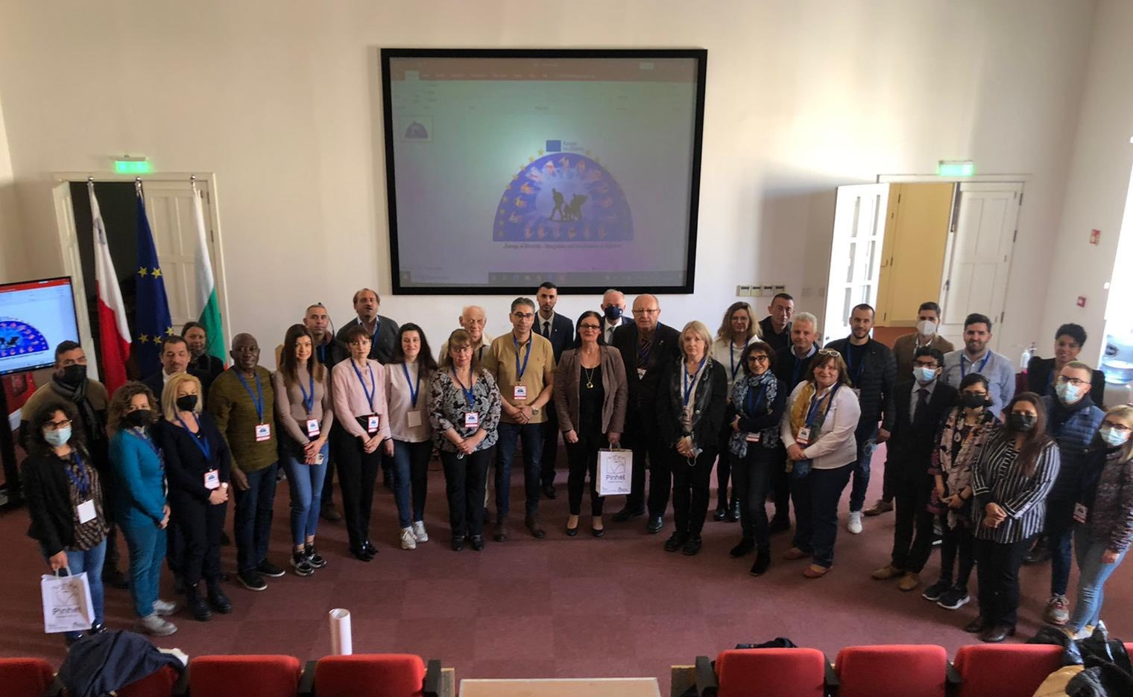Event 2: in the city of L-Imsida (Malta) from 15/02/2022 to 18/02/2022.

- 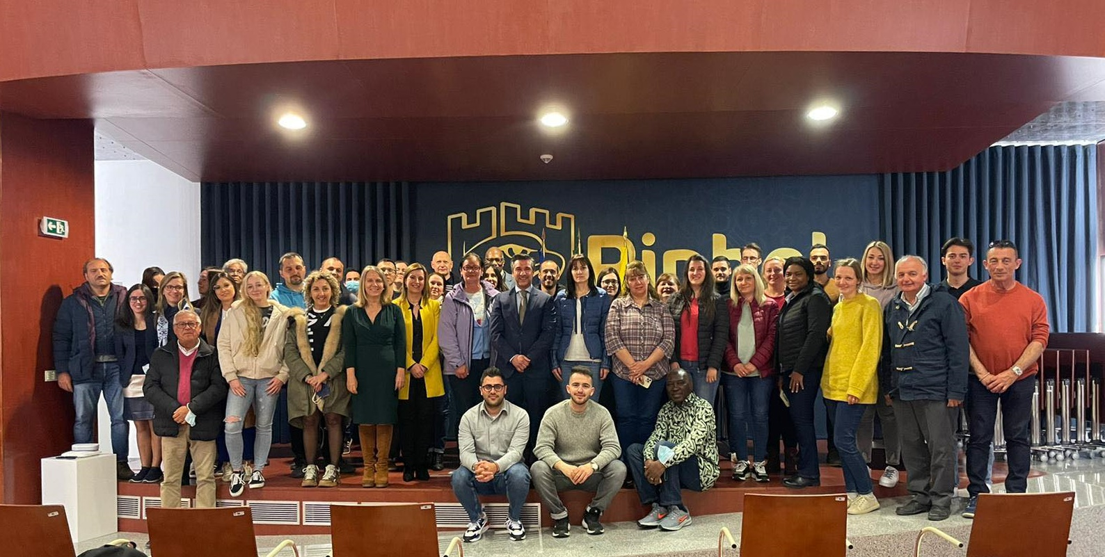Event 3: in the city of Pinel (Portugal) from 04/04/2022 to 04/07/2022.
- 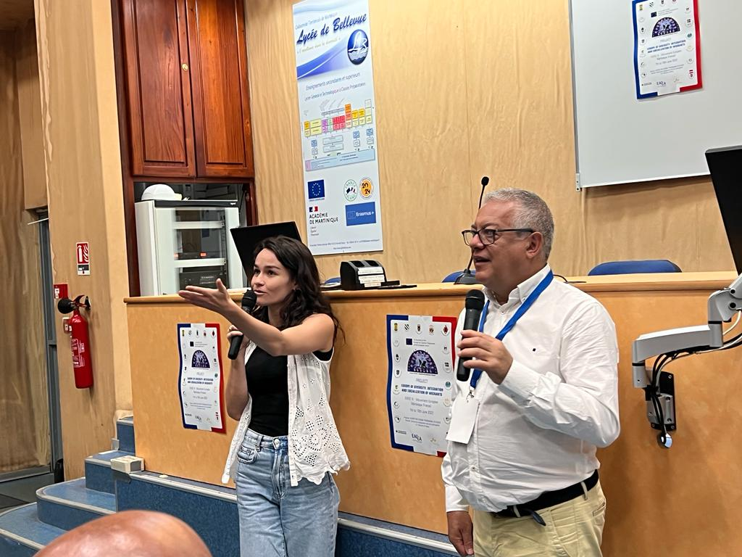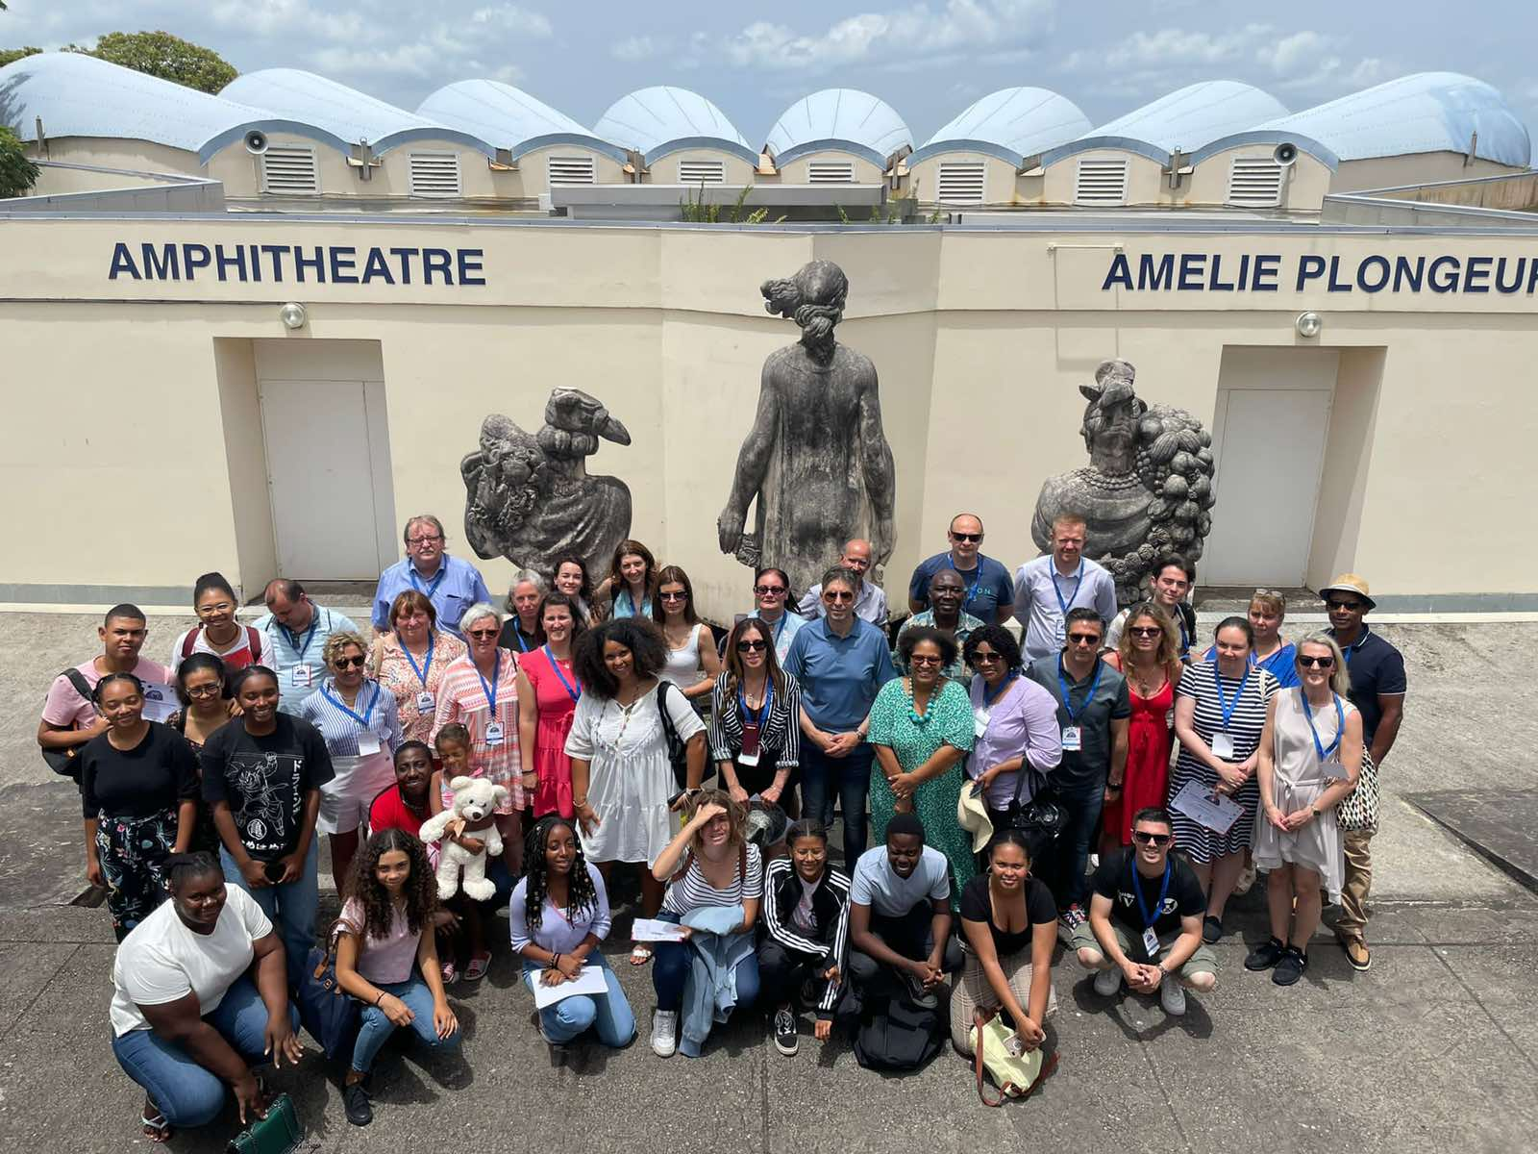Event 4: in the city of Gros Morne on the island of Martinique (France) from 07/06/2022 to 10/06/2022.
- Event 5: in the city of Holoko (Hungary) from 19/09/2022 to 22/09/2022.
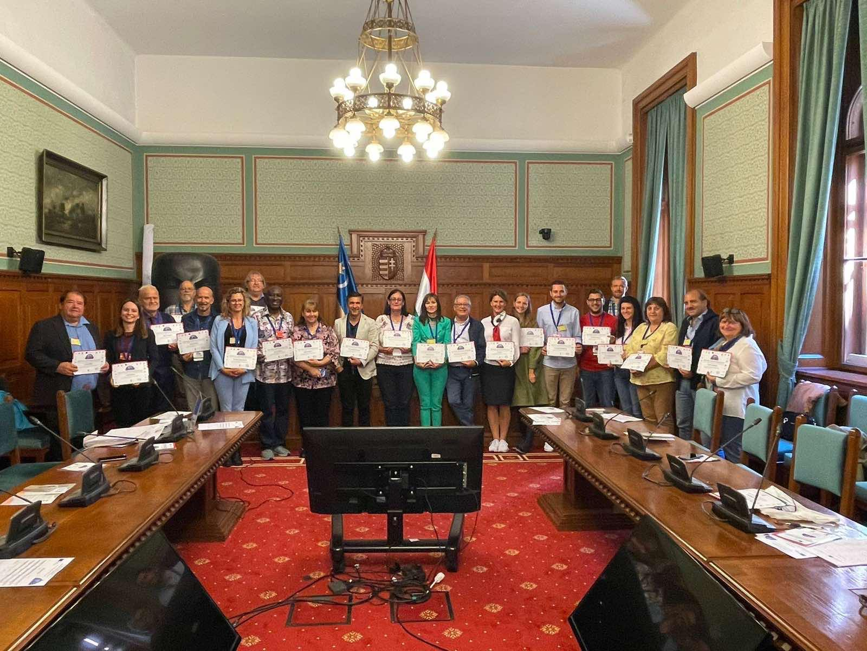

In order to achieve the objectives of the project, in line with the priorities of the Europe for Citizens program, the project allowed to create a long-lasting and long-term network open to the values of friendship, solidarity, intercultural dialogue and interaction between citizens with a "bottom-up" approach to the European program.
The presented project achieved its main goal, namely to find a solution to a number of problems arising from the migration crisis observed in Europe. Therefore, the participants were encouraged to exchange opinions and best practices, with which they successfully formulated new ideas and concrete proposals for the project.

