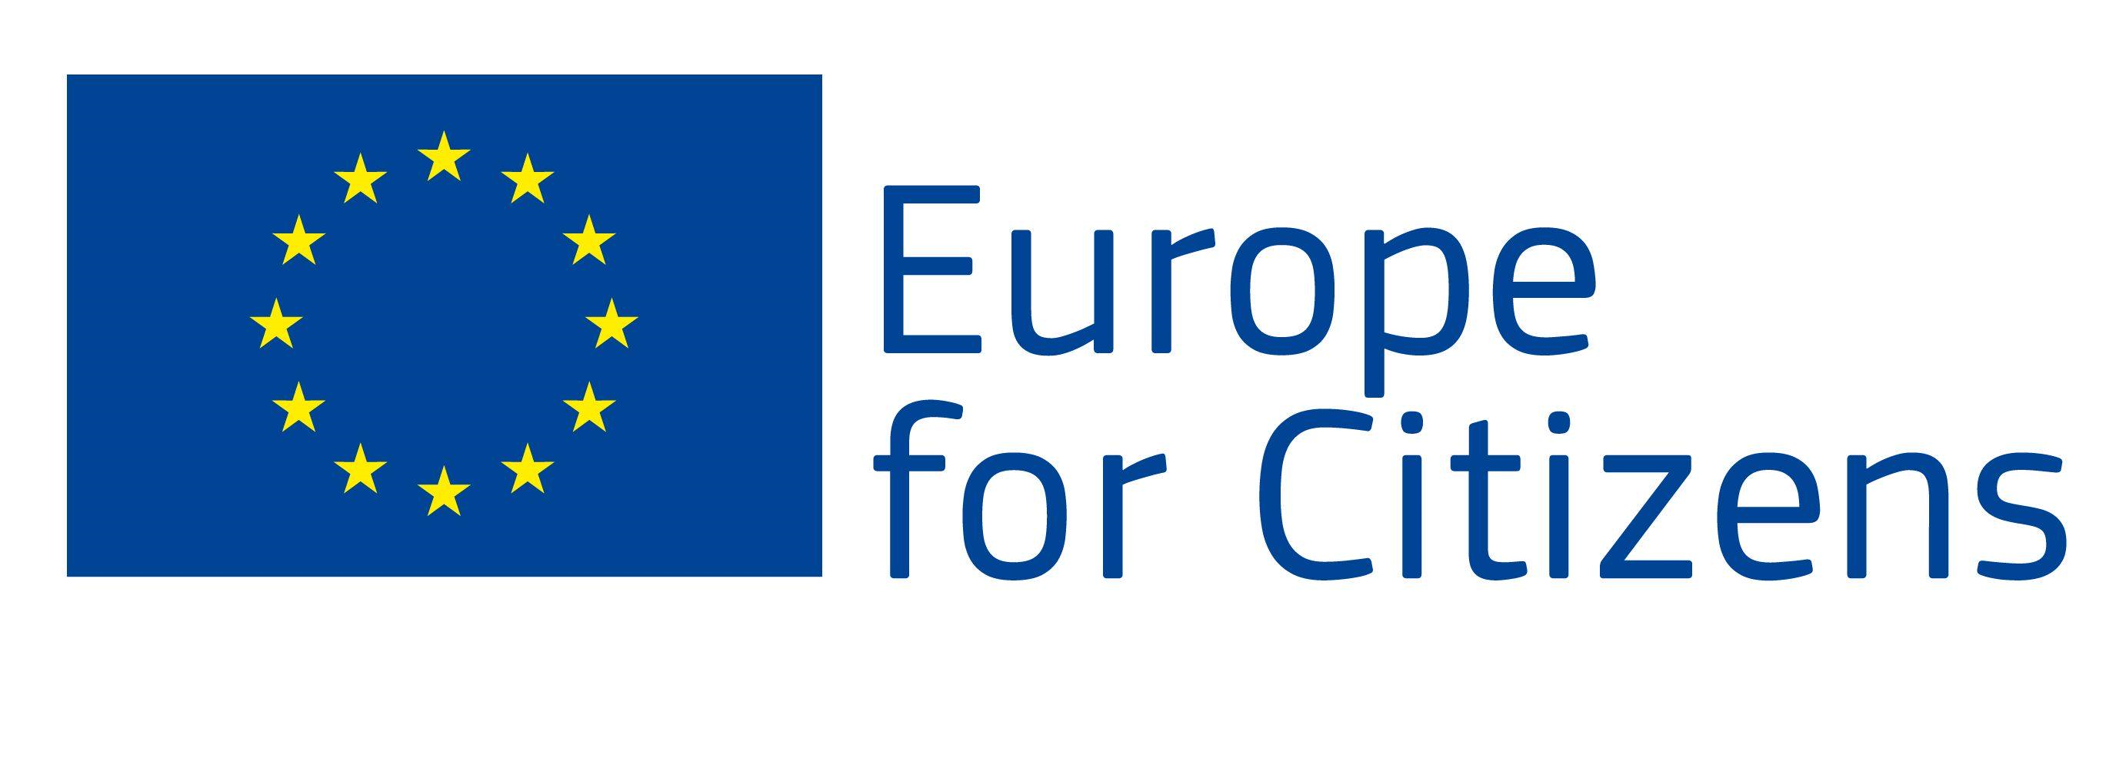

The project "Europe of Diversity - Integration and Socialization of Migrants" is funded by the European Union under the "Europe for Citizens" program
Applicable to Strand 2: Measure 2.2 "Networks of towns"
5 international events were organized under this project:

Event 1
Participation: the event allowed to gather 78 citizens, of which 40 are from the Municipality of Knezha (Bulgaria), 8 from the city of Pleven (Bulgaria), 2 from the Municipality of Negreira (Spain), the Municipality of Santa Ana, Guadalupe (France), 2 from the city of Berlin (Germany), 2 from the city of Holoko (Hungary), 2 from the city of Santa Teresa di Riva (Italy), 2 from the city of L-Imsida (Malta), 2 from the city of Amata (Latvia), 2 from the city of Pinhel (Portugal), 2 from the city of Valga (Estonia), 2 from the city of Kolonda (Slovakia), 2 from the city of Olesnica (Poland), 2 from the city of Stockholm (Sweden), 2 from the municipality of Poienarii de Arges (Romania), 2 from the city of Zagreb (Croatia), 2 from the city of Thessaloniki (Greece) and 2 from the village of Athienou (Cyprus).

Place/Date: the event took place in the city of Knezha (Bulgaria) from 30/08/2021 to 03/09/2021.

Short description: The purpose of the event was to make the international cooperation between the partner countries stronger and more sustainable, by expanding the established Network of Cities, to present the current situation in Europe and to raise the question of: "Integration and socialization of migrants, through their acceptance by the local community". The delegations were met and welcomed by the mayor of Knezha Municipality and local representatives. A presentation was made, both of the project and of the partners. They, in turn, presented information about migration and migrants in their settlements - the difficulties, problems, solutions and consequences of this process. At an official solemn ceremony in the city of Knezha, a Twinning Pact was signed between the European partners, with which the foundations were laid for joint work, creation of development opportunities and partnership in future project cooperation activities. During the event, a round table was also held in the city of Pleven, with the participation of the regional governor of the Pleven Region, as well as leading experts in charge of migration and migrant issues. A meeting was also organized in the city of Sofia in the National Assembly of the Republic of Bulgaria, where the topic "Migration - economic, political and social consequences" was discussed at a conference, with the participation of the Speaker of the National Assembly and deputies from the Committee on Foreign Policy in Bulgaria. A tour and introduction to the cultural and historical sights of the city of Sofia was organized. The event ended with a discussion on the assessment and first impressions of the partners from the first event held in Bulgaria, as well as marking main topics for the next event in Malta.

Event 2
Participation: the event allowed to gather 60 citizens, of which 30 are from the city of L-Imsida (Malta), 4 are from the city of Knezha (Bulgaria), 2 from the city of Pleven (Bulgaria), 2 from the municipality of Negreira (Spain), 1 from city of Le Lamentin, island of Martinique (France), 1 from the city of Berlin (Germany), 2 from the city of Holoko (Hungary), 3 from the city of Santa Teresa di Riva (Italy), 1 from the city of Amata (Latvia), 3 from the city of Pinhel ( Portugal), 1 from the city of Valga (Estonia), 1 from the city of Kolonda (Slovakia), 1 from the city of Olesnica (Poland), 1 from the city of Stockholm (Sweden), 2 from the municipality of Poienarii de Arges (Romania), 2 from the city of Zagreb (Croatia ), 2 from the city of Thessaloniki (Greece) and 1 from the village of Atienou (Cyprus).

Place/Date: the event took place in the city of L-Imsida (Malta) from 15/02/2022 to 18/02/2022.

Short description: The purpose of the event was to raise awareness among local administrations, voluntary associations and citizens about migration within the borders of the European Union. During the visit, workshops were held to discuss topics related to research and analysis of the efforts of the international community to find long-term and durable solutions for the integration and socialization of migrants. During the seminar, topics related to the thinking of the society "No prejudices, no stereotypes for diversity" were discussed, as well as the topic "Intercultural society, integration and socialization". Updates on findings and activities from the Faculty of Social Welfare in Malta were presented and a Migration Platform was also presented by a Research Support Officer. Within the framework of the event, a visit to the Parliament in Malta took place, where, together with national representatives, a working session and discussion with the partners was held, and they expressed their opinions and points of view. Major objectives under Malta's National Integration Program were also presented. The delegations were also able to visit the building of the Municipality of L-Imsida, where together with the hosts they made a summary of the past activities of the event and discussed new ideas for the next planned event of the project in Portugal.

Event 3
Participation: the event allowed to gather 74 citizens, of which 42 are from the city of Pinhel (Portugal), 3 are from the city of Knezha (Bulgaria), 2 from the city of Pleven (Bulgaria), 1 from the municipality of Negreira (Spain), 2 from the city of Le Lamentin , the island of Martinique (France), 2 from the city of Berlin (Germany), 2 from the city of Holoko (Hungary), 2 from the city of Santa Teresa di Riva (Italy), 3 from the city of L-Imsida (Malta), 2 from the city of Amata (Latvia ), 2 from the city of Valga (Estonia), 2 from the city of Kolonda (Slovakia), 2 from the city of Olesnica (Poland), 2 from the city of Stockholm (Sweden), 1 from the municipality of Poienarii de Arges (Romania), 2 from the city of Zagreb (Croatia) , 1 from the city of Thessaloniki (Greece) and 1 from the village of Atienou (Cyprus).

Place/Date: the event took place in the city of Pinhel (Portugal) from 04/04/2022 to 07/04/2022.

Short description: The purpose of the event was to hear the voices of vulnerable groups, to encourage the civic participation of migrants - why they chose Europe and how they see their future among other cultures. The event brought together both project partners and local community representatives, many students, teachers, experts and representatives of NGOs from the Pinhel region. A European conference was held presenting Pinhel's experience in the integration of migrants at the local and regional level. The topic "Unaccompanied Migrants - Family Accommodation Solution" was also included, presenting the LAR project - a project for the integration of refugees/migrants in Portuguese rural areas. Migrants living in the Pinhel area got involved, presenting their stories and the hardships they went through to get here. Within the framework of the event, the topic "Racism and xenophobia in the era of globalization" is debated - with the participation of migrants who have overcome situations of racism or xenophobia. The partners exchanged good practices on the social inclusion of migrants, as well as "Challenges for the future of Europe", by promoting equality and cultural coexistence.

Event 4
Participation: the event allowed to gather 54 citizens, of which 34 are from the city of Gros Morne, Martinique Island (France), 3 from the city of Knezha (Bulgaria), 2 from the city of Pleven (Bulgaria), 1 from the municipality of Negreira (Spain), 1 from the city of Berlin (Germany), 1 from the city of Holoko (Hungary), 1 from the city of Santa Teresa di Riva (Italy), 1 from the city of L-Imsida (Malta), 1 from the city of Amata (Latvia), 1 from the city of Pinhel ( Portugal), 1 from the city of Valga (Estonia), 1 from the city of Kolonda (Slovakia), 1 from the city of Olesnica (Poland), 1 from the city of Stockholm (Sweden), 1 from the municipality of Poienarii de Arges (Romania), 1 from the city of Zagreb (Croatia ), 1 from the city of Thessaloniki (Greece) and 1 from the village of Atienou (Cyprus).

Place/Date: the event took place in the city of Gros Morne on the island of Martinique (France) from 07/06/2022 to 10/06/2022.

Short description: The purpose of the event was to promote sustainable cooperation between cultures and to debate topics for future initiatives related to the socialization of migrant flows. The project partners were duly welcomed by the local communities of Martinique and had the opportunity to discuss the topic "Culture, Multiculturalism and Interculturalism". Within the framework of the event, a meeting was held at the Parliament of St. Joseph, where together with local politicians and experts a discussion was held on "Problems, solutions and consequences of migration flows", and participants shared their good practices. Presentations on "Schengen Asylum and Free Movement" and "European Immigration Fund" were presented at an organized conference. The delegations were able to get to know the historical and cultural attractions of Martinique.

Event 5
Participation: the event allowed to gather 57 citizens, of which 35 are from the city of Holoko (Hungary), 3 from the city of Knezha (Bulgaria), 2 from the city of Pleven (Bulgaria), 1 from the municipality of Negreira (Spain), 2 from the city of Gros-Morne , the island of Martinique (France), 1 from the city of Berlin (Germany), 1 from the city of Santa Teresa di Riva (Italy), 1 from the city of L'Imsida (Malta), 1 from the city of Amata (Latvia), 1 from the city of Pinhel (Portugal ), 1 from the city of Valga (Estonia), 2 from the city of Kolonda (Slovakia), 1 from the city of Olesnica (Poland), 1 from the city of Stockholm (Sweden), 1 from the municipality of Poienarii de Arges (Romania), 1 from the city of Zagreb (Croatia) , 1 from the city of Thessaloniki (Greece) and 1 from the village of Atienou (Cyprus).

Place/Date: the event took place in the city of Holoko (Hungary) from 19/09/2022 to 22/09/2022.

Short description: The purpose of the event was to meet the needs of citizens and local authorities by exchanging good practices on issues related to migration and European diversity. During the event, a round table was organized on the topic "Integration and socialization of migrants in the European Union", as well as an open debate was held on the topic "Local, regional and European migration policies", with the participation of all partners, local experts and representatives of NGOs organizations. At a conference organized in the Parliament of Hungary, a discussion was held on "Is the labor market open to immigrants?" and the partner views on "Diversity + integration = European Engagement" were presented. A closing ceremony was also organized, attended by local politicians, citizens and guests from the region. A video was presented with key moments and fond memories of the overall implementation of all events under the "Europe of Diversity - Integration and Socialization of Migrants" project. Within the framework of the event, the achieved results of the project were summarized and proposals for new projects resulting from the cooperation network of the partner organizations were discussed.

